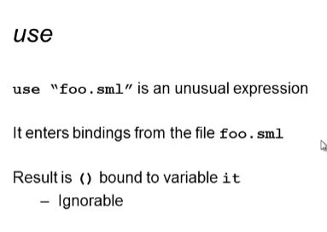

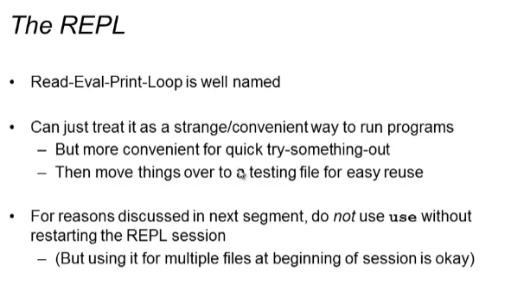

Restarting the session if you will be using another/same file again

1. End the REPL session: C-d

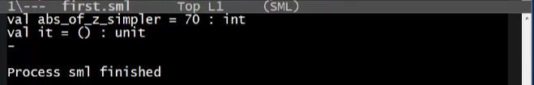

1. C-c C-s to enter the sml terminal again
2. Then “use” again

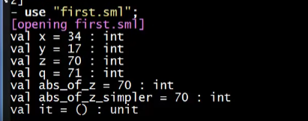

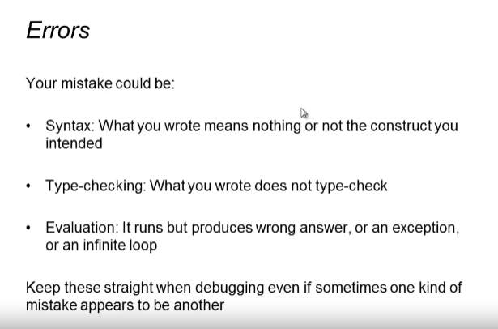

* Not all the error results point out directly to the error BUT it serves as a guide/hint where to look at

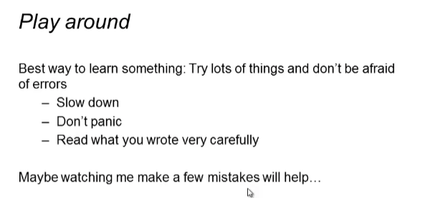

Trying errors.sml

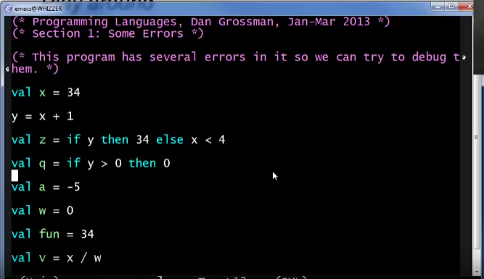

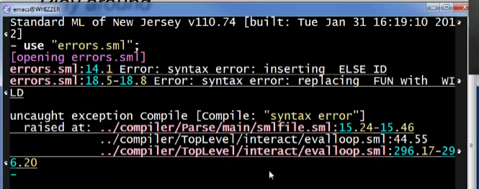

1st one :



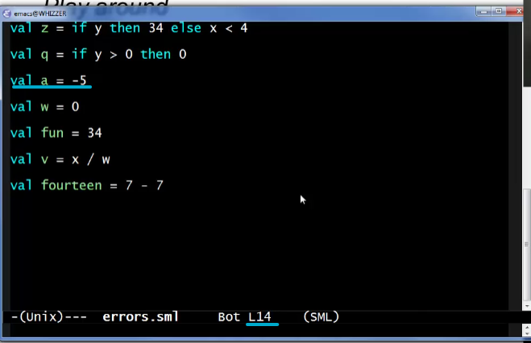

But here are no conditionals here. Most often the errors are BEFORE the line of the error. So check the above statement:

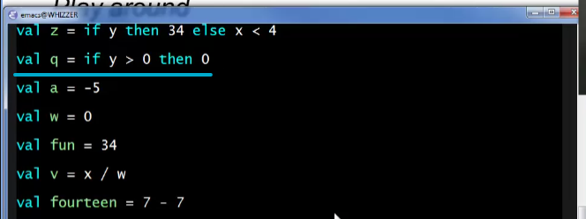

The error is suggesting if you want to put ELSE in line 14!

But we want to put it here in line 12 instead and it’s totally fine

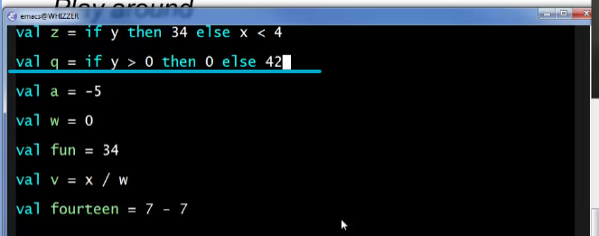

Conditionals here must have an ELSE statement always

Save the file and restart the sml session

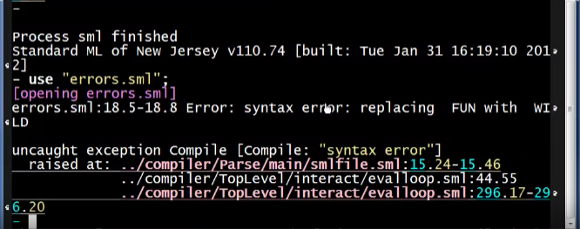

Let’s now proceed to the next error

2nd one:



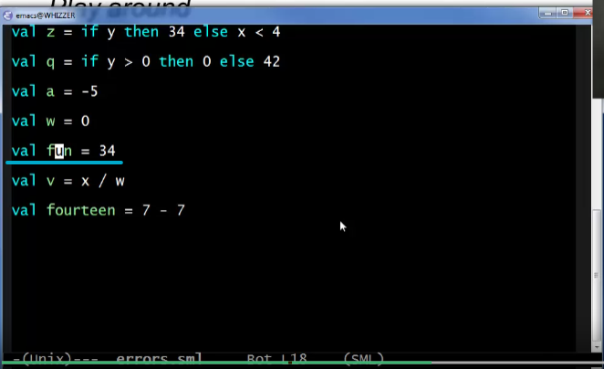

“fun” is a reserved keyword! We need to change this variable name:



Save and restart session

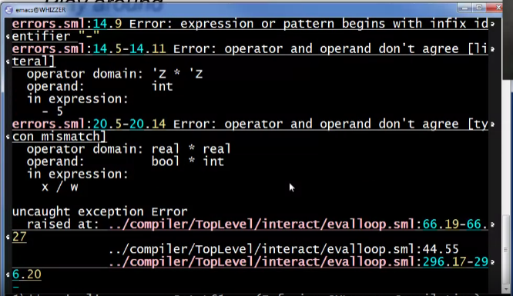

After fixing all syntax errors, all the runtime errors will now be displayed!

Fixing the runtime errors one at a time, first thing first

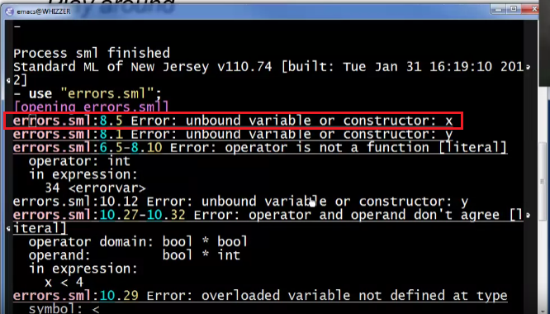

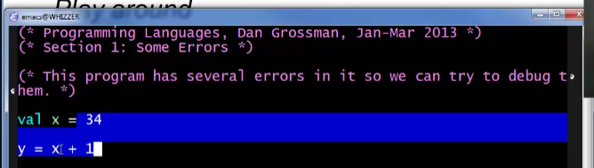

Compiler thinks this is one expression. But in reality, this is just a syntax error! Y does not have val

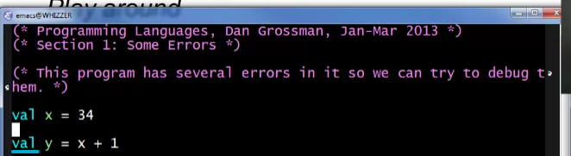

Save and restart session. Error now gone!

Proceed to the next error!

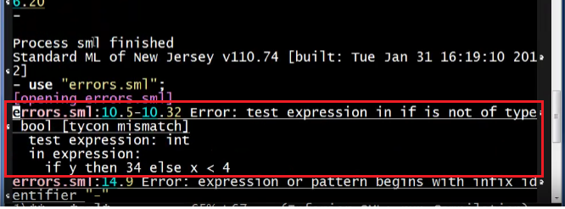



Y must be bool!



Save and restart

Proceed to the next error!

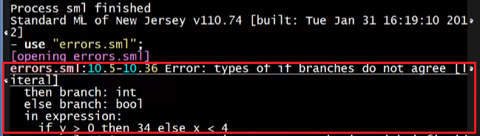





Save and restart

Proceed to the next error!

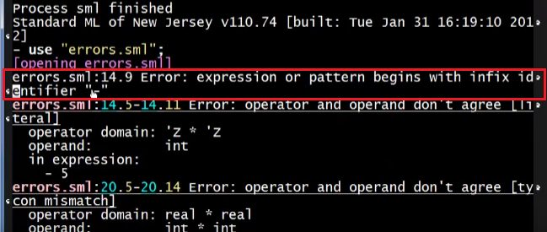



You cannot use – as a primitive operator for negative numbers!

Syntax to write a negative number: you have to use ~



Save and restart session

Proceed to the next error!

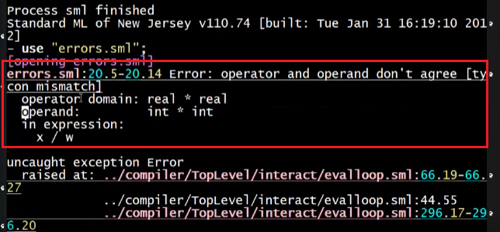



Forward slash is only for real numbers but not integers!

Use “div” instead



Save and restart session

Proceed to the next error!

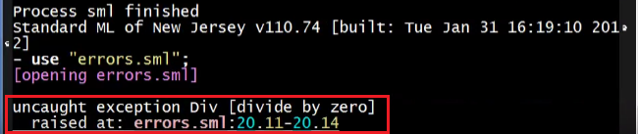

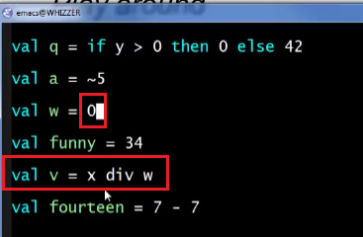

You cannot divide by 0!

We can have a different divisor



Save and restart session:

 -> THIS IS THE RESULT OF “use”

Checking results

 -> I don’t want this result or this result is not the one I expected

Check the expression:



Correct the expression:



Save and restart session: ALL DONE